Core java:- https://www.javatpoint.com/what-is-core-java

Jvm:- https://www.javatpoint.com/jvm-java-virtual-machine

Garbage collector:- https://www.oracle.com/webfolder/technetwork/tutorials/obe/java/gc01/index.html

Collection Frame work:-
https://www.programiz.com/java-programming/collections
https://beginnersbook.com/java-collections-tutorials/

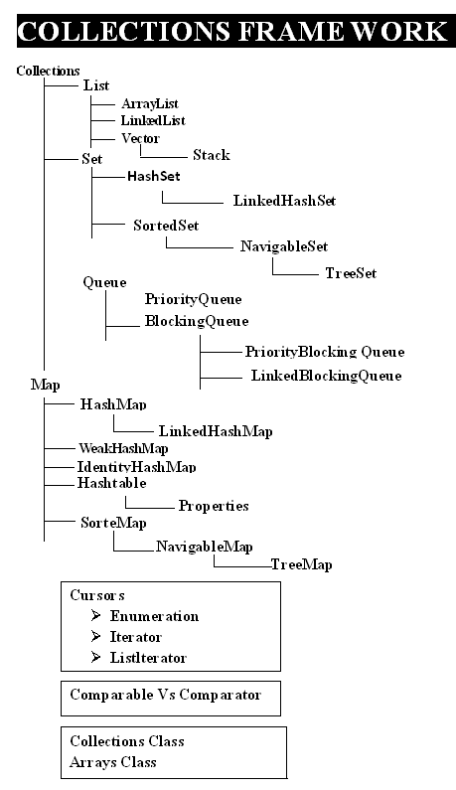

Internal implementation of hash map:-
https://prateeknima.medium.com/internal-working-of-hashmap-in-java-e5b67890e152

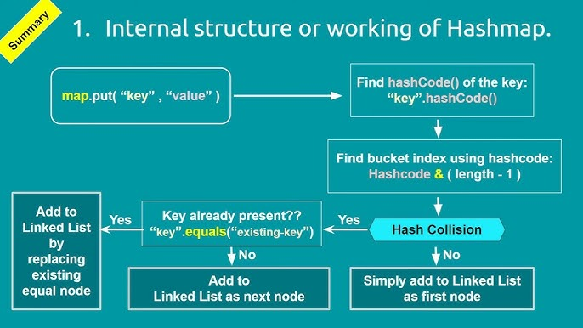

To Iterate given collection(Cursors):-
https://www.geeksforgeeks.org/iterators-in-java/

Serialization and DeSerialization:-
https://www.baeldung.com/cs/serialization-deserialization

Executor Service:-

Ways to create a Thread pool
1)Fixed Sized Thread Pool Executor :-
ThreadPoolExecutor executor = (ThreadPoolExecutor) Executors.newFixedThreadPool(10);
Creates a thread pool that reuses a fixed number of threads to execute any number of tasks. If additional tasks are submitted when all threads are active, they will wait in the queue until a thread is available.
.Cached Thread Pool Executor
ThreadPoolExecutor executor = (ThreadPoolExecutor) Executors.newCachedThreadPool();
Creates a thread pool that creates new threads as needed, but will reuse previously constructed threads when they are available.
Single Thread Pool Executor:-
ThreadPoolExecutor executor = (ThreadPoolExecutor) Executors.newSingleThreadExecutor();
Creates a single thread to execute all tasks. Use it when you have only one task to execute.

Scheduled Thread Pool Executor:-
ThreadPoolExecutor executor = (ThreadPoolExecutor) Executors.newScheduledThreadPool(10);
Creates a thread pool that can schedule commands to run after a given delay or to execute periodically.

execute() method doent return anything return type is void
submit() method submits a Callable or a Runnable task to an ExecutorService and returns a result of type Future:
Future<String> future = executorService.submit(callableTask);

invokeAny() assigns a collection of tasks to an ExecutorService, causing each task to run, and returns the result of a successful execution of one task (if there was a successful execution):
String result = executorService.invokeAny(callableTasks);
invokeAll() assigns a collection of tasks to an ExecutorService, causing each task to run, and returns the result of all task executions in the form of a list of objects of type Future:
List<Future<String>> futures = executorService.invokeAll(callableTasks);

